Deployment of The Daily Plan inside the Sandbox Environment

Version 1.0

January, 2011

**Table of Contents**

1 TDP® Overview 3

1.1 Subversion 3

1.2 Subversion Clients 3

1.2.1 Repository Browsing 4

1.2.2 Checkout 4

1.3 Build Scripts 6

1.3.1 Running the Ant script 6

2 Deployment 6

3 Testing 6

3.1 Test Accounts 7

**Table of Figures**

Figure 1 - Sub-folders 3

Figure 2 - Repository Browser 4

Figure 3 - Repository Checkout 5

Figure 4 - Repository Checkout Completed 5

**Revision** **History**

|  |  |  |  |
| --- | --- | --- | --- |
| Date | Revision Description | Version# | Responsible |
| 1/26/2011 | TDP® Final Release checkout procedure | V1.0 | Mark Rosenthal |

# TDP® Overview

The Daily Plan (TDP) was developed on a VA issue laptop. The final source code was then uploaded to the Innovation Sandbox for the NCPS team to use as a demonstration tool. Data used for the development of TDP was based on data inputs from the NCPS team and the Technik Team. Requirements for the development of the TDP® were based on the project spec’s identified in the proposal. There were three (3) releases involved in this effort, they were:

* Initial Release
* Interim Release
* Final Release

Each release was tested within the laptop environment prior to the code being checked into the Sandbox.

## Subversion

In the Innovations Sandbox, check out the source code from the following URL’s:

* **10.186.19.136/tdp/Trunk/TdpApp**
* **10.186.19.136/tdp/Trunk/TdpWeb**
* **10.186.19.136/tdp/Trunk/shared**

Once complete, you should have three sub-folders located in the same directory at the same level. For example:

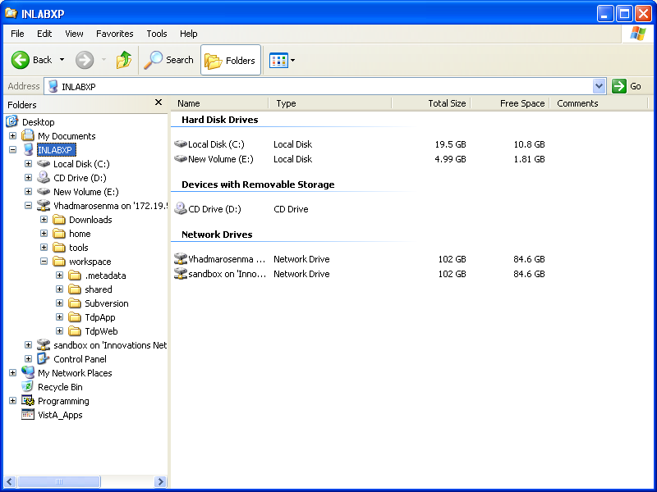

Figure - Sub-folders

## Subversion Clients

There are numerous tools available for accessing Subversion, including many that fully integrate with Development editors such as Eclipse, NetBeans and Visual Studio. A very popular tool that integrates with Windows Explorer is TortoiseSvn, which is a freely available download. It includes a graphical interface for most SVN commands.

### Repository Browsing

Right-clicking a folder, and selecting TortoiseSVN and Repo Browser will allow displaying the contents of a repository. The client will prompt for a password numerous times, so it is best to save your password to the clipboard, and paste it every time the prompt is displayed.

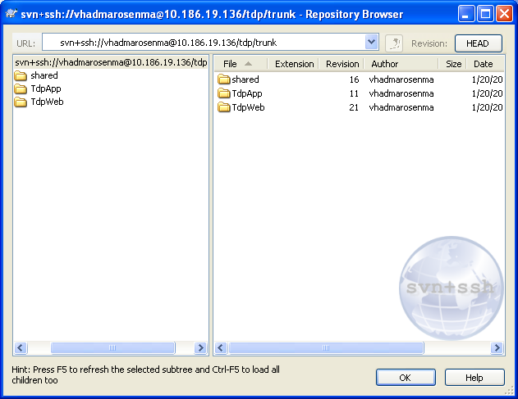

Figure - Repository Browser

### Checkout

To check out a project from the repository,, right-click the folder where you would like the working copy to be placed. It the previous example, this would be the workspace folder. In this case, it is the S:\TheDailyPlan\temp folder. You will be prompted again for your password, so have it handy: If the repository does not list the proper project, for example TdpApp, you may navigate to the project by clicking the ellipses (…) next to the repository.

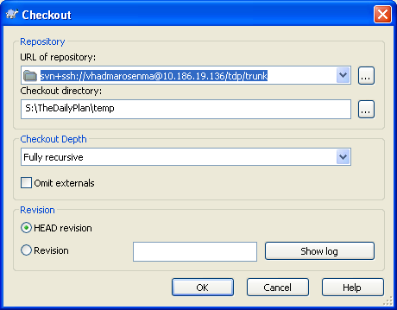

Figure - Repository Checkout

When you are happy with the contents, click okay to begin checkout. You will see the progress after again being prompted for a password. When check out is complete, you will see the following dialog:

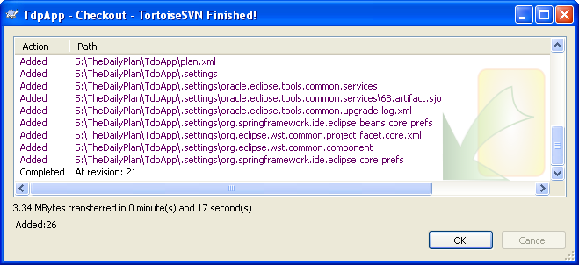

Figure - Repository Checkout Completed

## Build Scripts

Apache Ant is used as the build and deploy script. The main build file is located in the TdpWeb folder, and the TdpApp folder is expected to be at the same directory level.

### Running the Ant script

To run ant scripts from the command line, use bin\runant.cmd. Here is a list of useful commands:

* dist [default] – builds an Ear file which is suitable for deployment
* install – deploys the ear file to the vaphswls2 host listening on port 7001. These can be overridden by specifying values for ‘weblogic.host’ and/or ‘weblogic.port’ in build.properties
* reload-db – will initialize the database. This needs to be done after any schema changes.
* test – runs all unit tests. Test results are saved in target\test-reports

# Deployment

Deployment can be handled in one of two manners:

1. Run the bin\runant.cmd, and ensure that no errors are reported. Note that the generated ear file is saved in target\dist\tdpApp.ear. Log onto the console using weblogic/1qazxsw2, and navigate to deployments.
   1. If there is an existing tdpApp, select it and stop it. Select Lock & Edit, then select TdpApp, and delete. Respond YES to the confirmation, and then click Activate Changes, ensuring that the deployment is no longer shown.
   2. Select Lock & Edit, and then Click Install on the deployments page.
   3. Above the Path box, there is an ‘ upload your file(s)’ link. Select this.
   4. Next to Deployment Archive, Browse to the target\dist\tdpApp.ear file, and open
   5. Click next, accepting all defaults until the finish button is available, and then click it.
   6. Select Activate Changes, and note the the deployment is displayed with a State of distribute Initializing.
   7. Select the deployment, click Start and select Servicing all requests
2. Run bin\runant.cmd install, and ensure that the command runs without errors. Note that for this to work, the current version of Weblogic Server (10.3.3 or 11G) need to be installed, and a domain must have been created.

# Testing

Once the application has been deployed, and verified in the AdminServer console, it should be tested in a browser by pointing your browser to <http://vaphswls1:7001/tdp/> and logging on.

## Test Accounts

There are 2 test accounts which are set up. For testing purposes, any valid access/verify code can be used and will be identified as a Nurse. An admin assign an admin role to any other user after successful login, as well.:

1. **Nurse User:** This login emulates a Nurse at any given facility

Verify Code: vhaino321

Verify Access: verify123.

1. **Administrative User:** This login emulates an Administrator at either the facility of ‘Super User’ level.

Verify Code: vhaino111

Verify Access: verify123.

Note: The final digit is a period (.) and is the last digit of the access code.